Supplemental Information associated with “Machine learning photogrammetric analysis of images provides a scalable approach to study riverbed grain size distributions”.

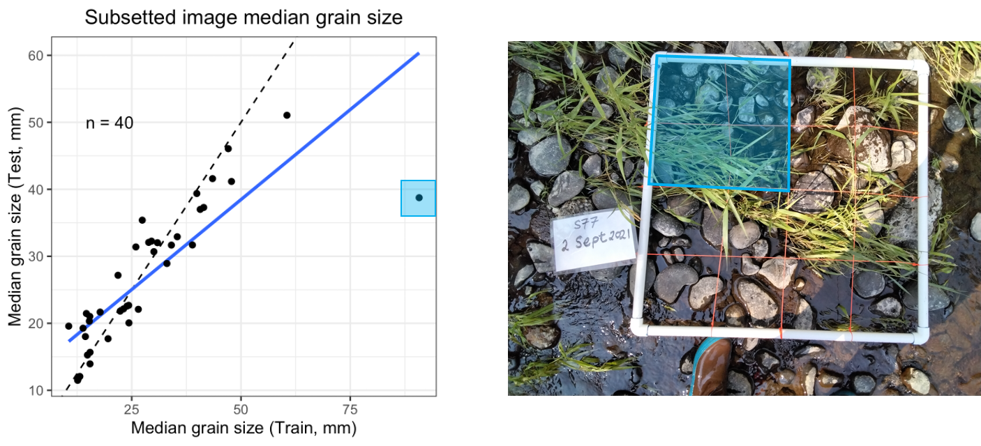

Figure S1: Figure 2B including one outlier that was removed prior to fit and error analysis. Both the outlier and the corresponding spatial extent within the training image are both highlighted in blue.

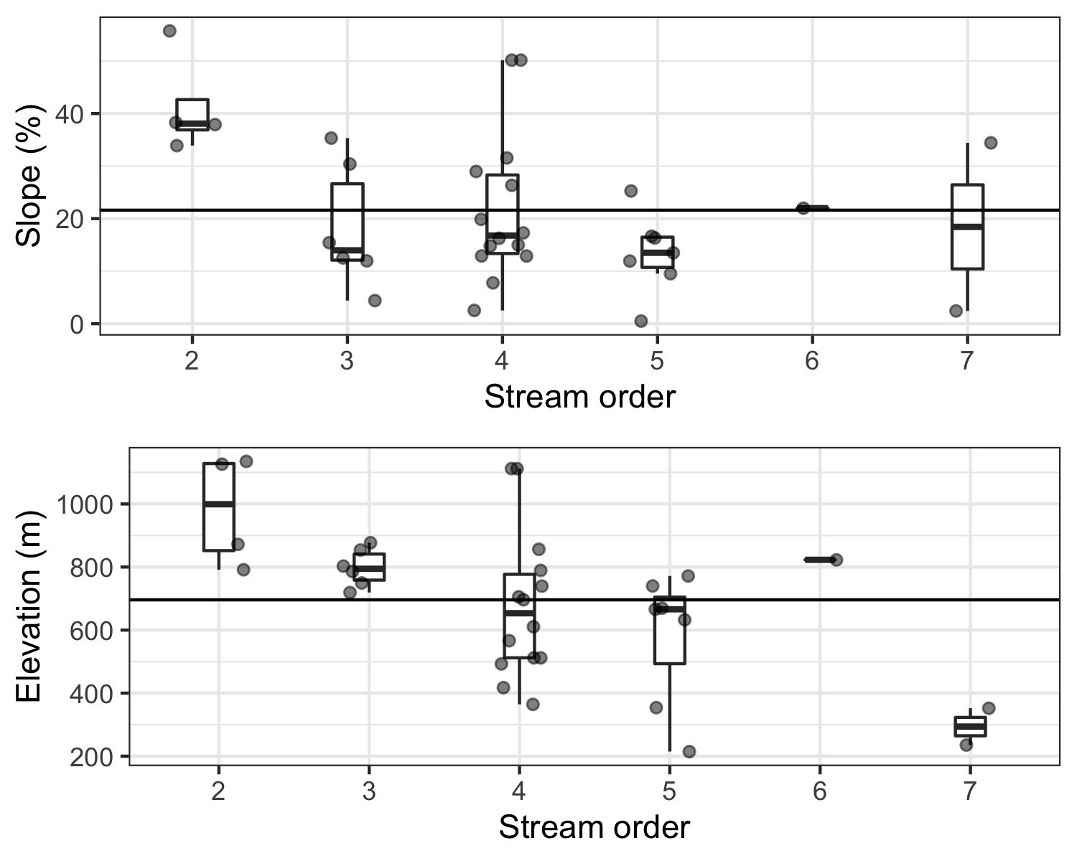

Figure S2: Catchment-scale site characteristics (average slope and elevation) by stream order.

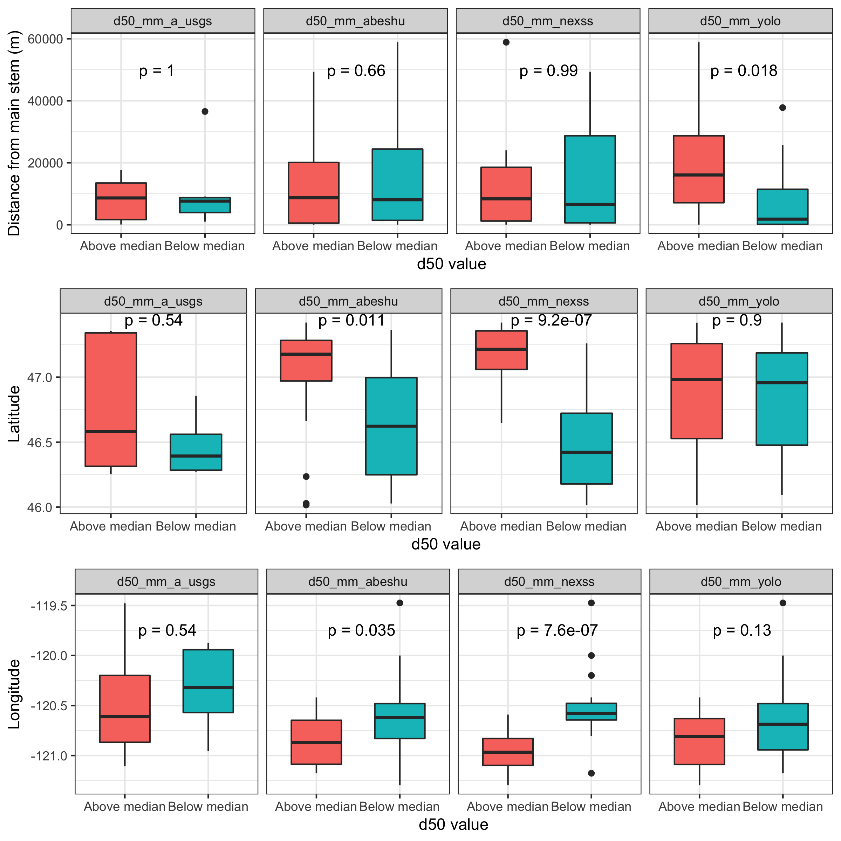

Figure S3: Boxplots that present statistics that accompany Figure 4. A) Straight-line distance in m of sites from the main stem of the Yakima, as shown in Figure 4, B) site latitude, and C) site longitude. Differences between means are presented as p-values, where significance is determined as p < 0.05.

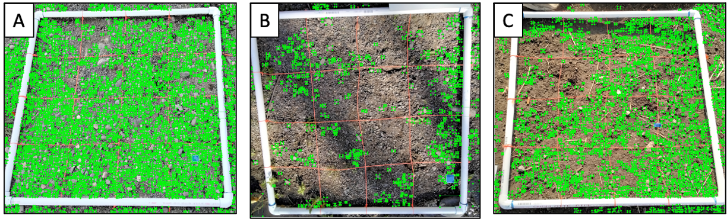

Figure S4: The photos corresponding to the outliers in the “Yes” group highlighted in Figure 7.

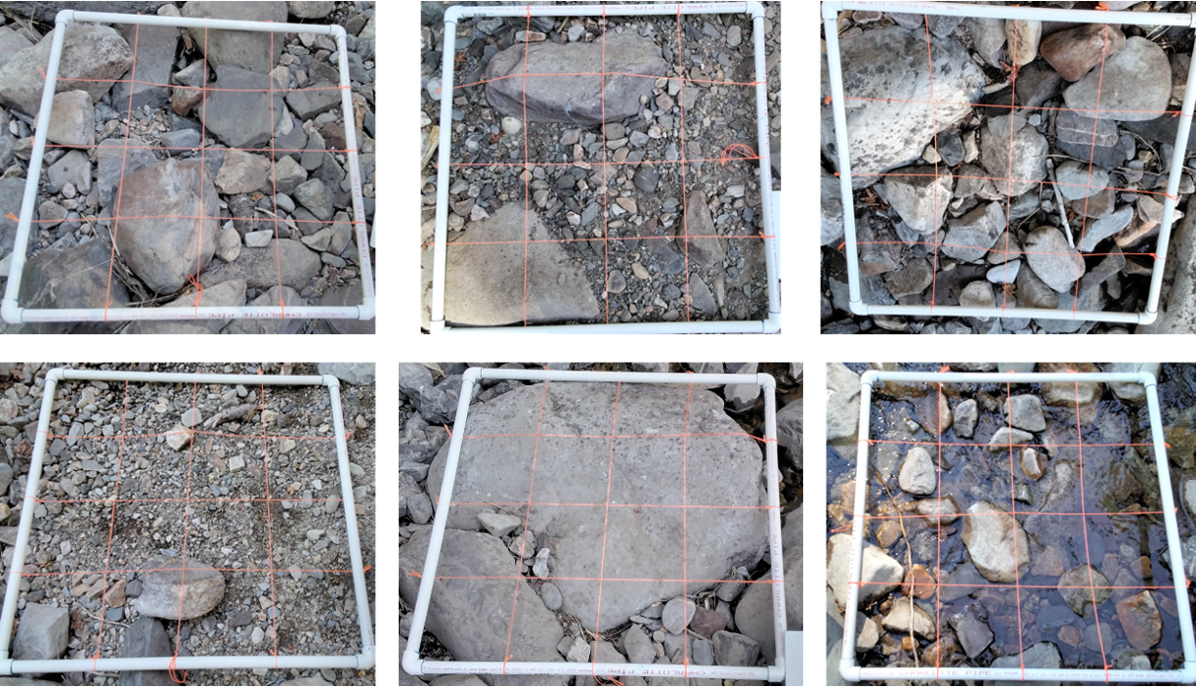

Figure S5: The 6 photos for Site 15.

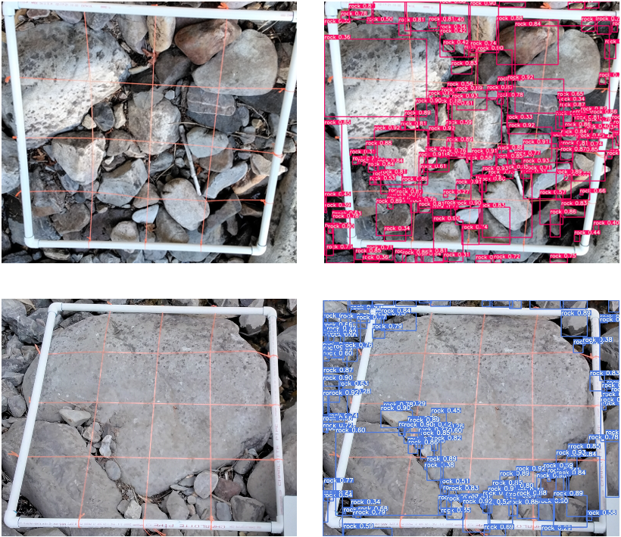

Figure S6: Comparison of the raw photo and YOLO prediction for photo C (upper row) and E (lower row).